“On my honour, as student of University of Engineering and Technology, I have neither given nor received unauthorized assistance on this academic work.”





**CSE102l Computer Programming Lab**

**Department of Computer System Engineering**

**University of Engineering and Technology Peshawar**

Submitted to: **Abdullah Hamid**

Submitted by: **Muhammad Saad**

Reg ID: **21PWCSE1997**

**DCSE , Batch 23 , Section “B”**



Student Signature: ____________

**Lab Report No: 03**

* **Introduction to Relational, Logical Operators, Selection Statements**

# Lab 3: Introduction to Relational, Logical Operators, Selection Statements

## Objectives:

To be familiar with Relational & Logical Operators

To understand the programming knowledge using Selection Statements (if, if-else, if-else ladder, Nested if-else and Switch)

## Task Titles:

1. Display the largest among three numbers using if else statement?
2. Check whether a number is even or odd?
3. Check the greater of two numbers using ternary operator?
4. Write a program where you print you take a number from the user if the number is greater than 2 and then print your name and registration number 2 times or else print only 1 time.
5. Write a program that asks a number and test the number whether it is multiple of 5 or not, divisible by 7 but not by eleven. (all three conditions should match)
6. Check whether the entered character is vowel or consonant?
7. Write a program that takes the weekday number as input from user and print the day name of week. E.g., Print Monday if weekday number is equal to 1. Similarly, check condition for all 7 days and print the corresponding day name. Print an error message if an invalid number is entered.
8. Write a C++ program to enter month number between (1-12) and print number of days in month.
9. Write a program to calculate and print the Electricity bill of a given customer. The customer id and unit consumed by the user should be taken from the keyboard and display the total amount to pay to the customer. The charges are as follow:

|  |  |
| --- | --- |
| **Unit** | **Charge/unit** |
| Up to 199 | @1.20 |
| 200 and above but less than 400 | @1.50 |
| 400 and above but less than 600 | @1.80 |
| 600 and above | @2.00 |

If bill exceeds Rs. 400 then a surcharge of 15% will be charged

**Test Data:**

1001

800

**Expected Output:**

Customer IDNO: 1001

Units Consumed: 800

Amount Charges @Rs. 2.00 per unit: 1600.00

Surcharge Amount: 240.00

Net Amount Paid by the Customer: 1840.00

**Lab Tasks**

**Task No 01:**

Display the largest among three numbers using if else statement?

Code

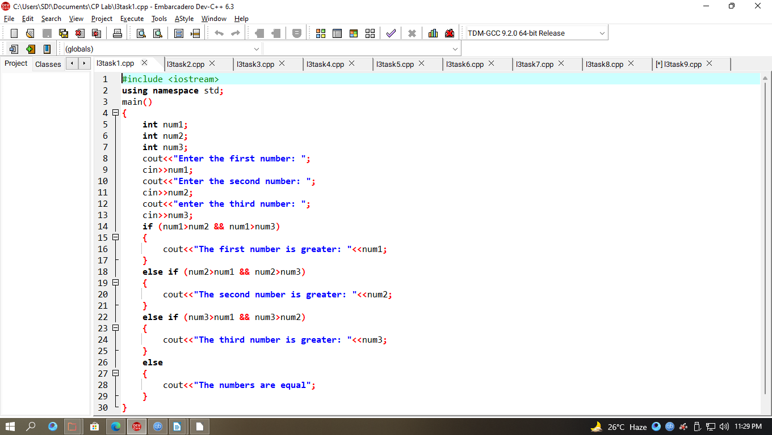

Output

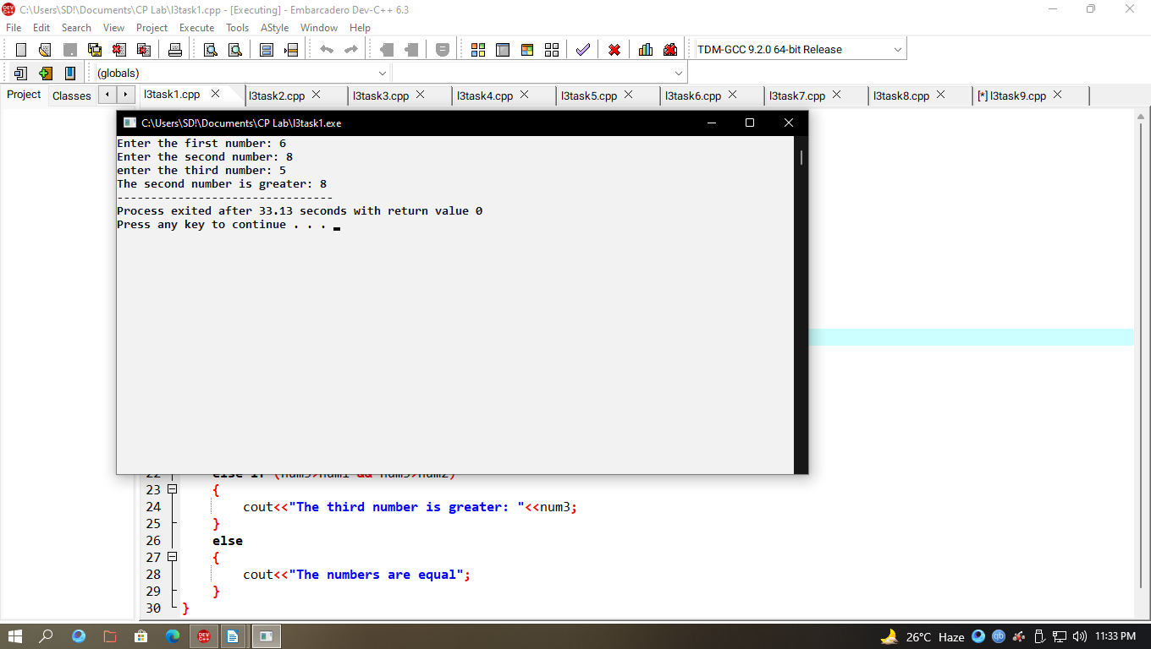

**Task No 02:**

Check whether a number is even or odd?

Code

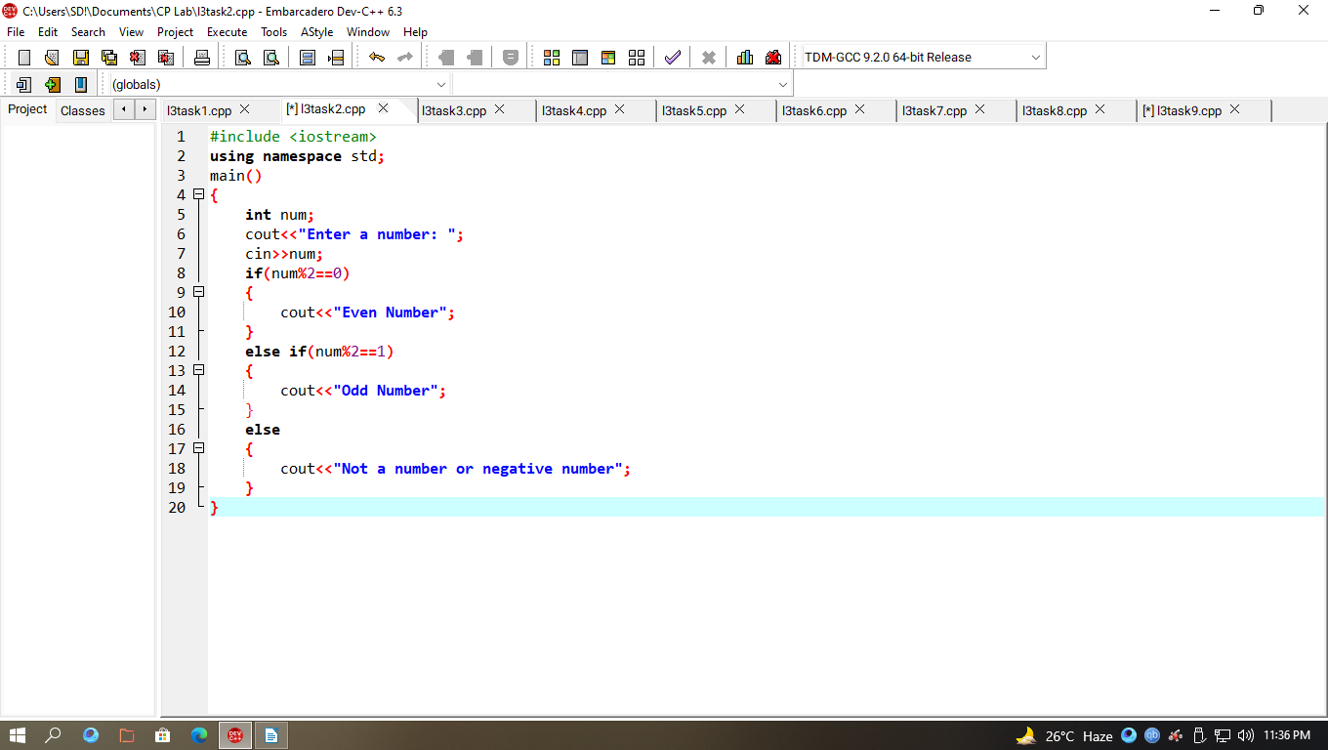

Output

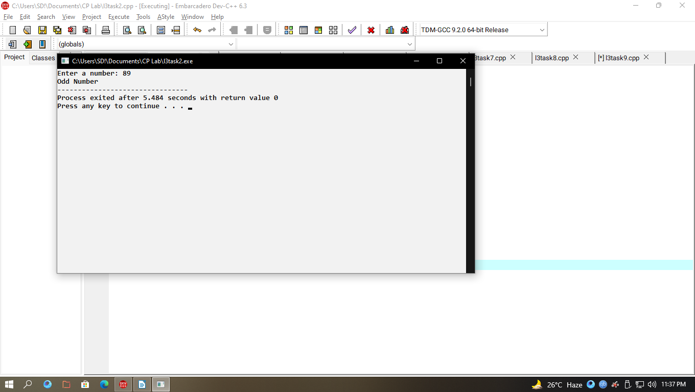

**Task No 03:**

Check the greater of two numbers using ternary operator?

Code

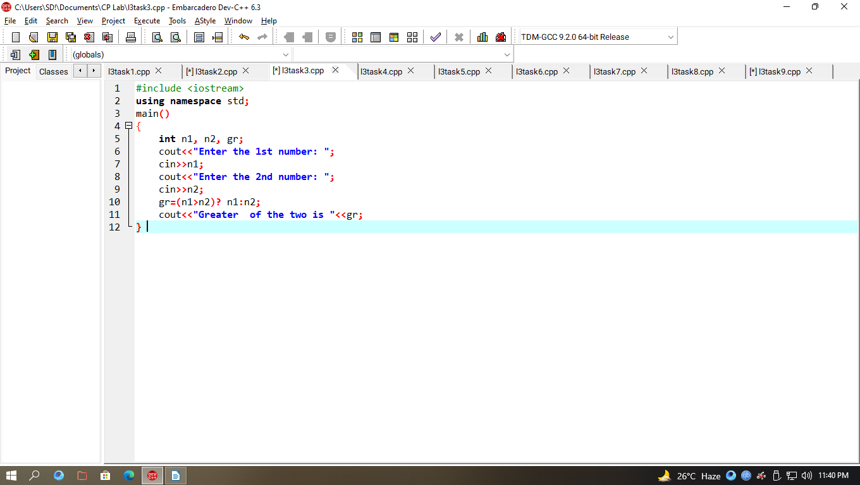

Output

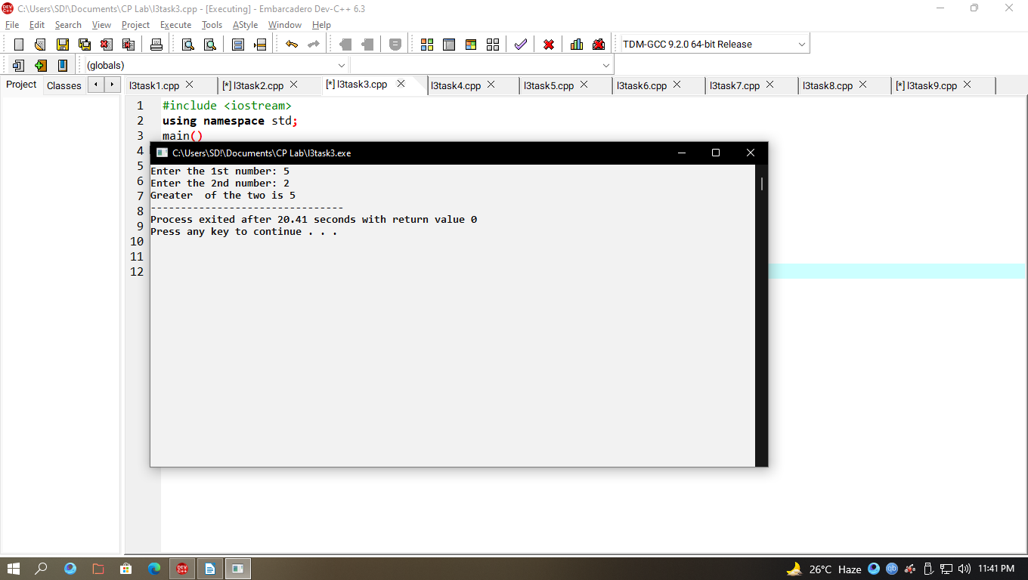

**Task No 04:**

Write a program where you print you take a number from the user if the number is greater than 2 and then print your name and registration number 2 times or else print only 1 time.

Code

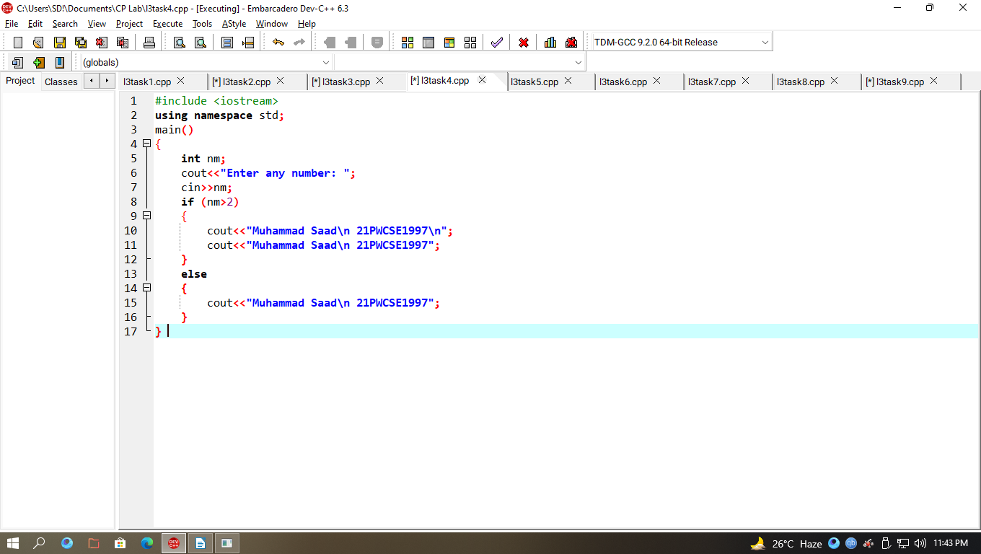

Output

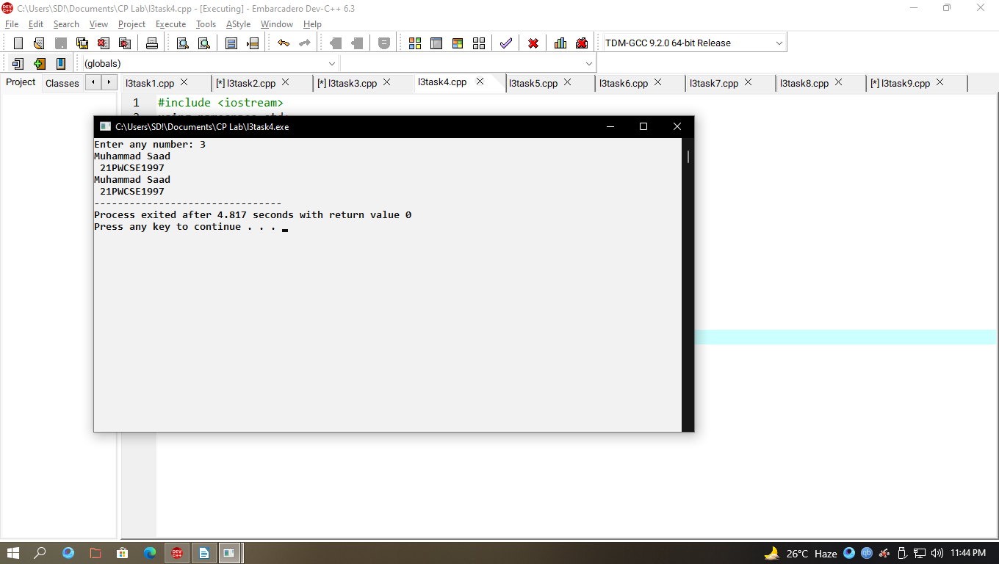

**Task No 05:**

Write a program that asks a number and test the number whether it is multiple of 5 or not, divisible by 7 but not by eleven. (all three conditions should match)

Code

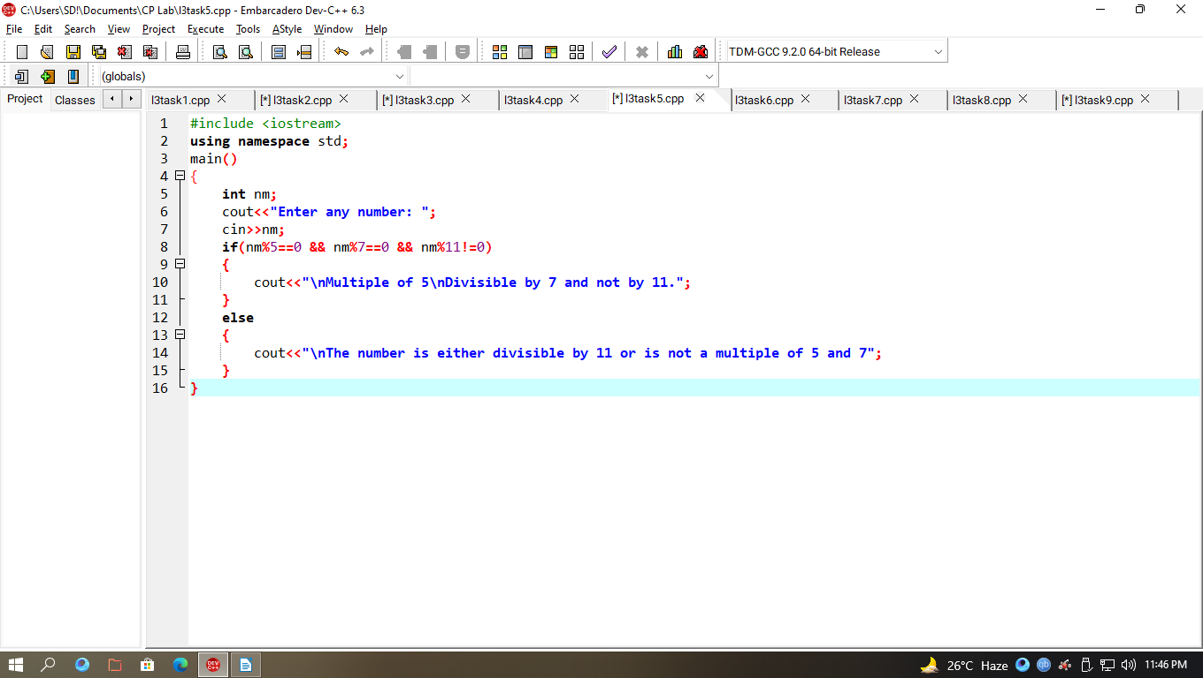

Output

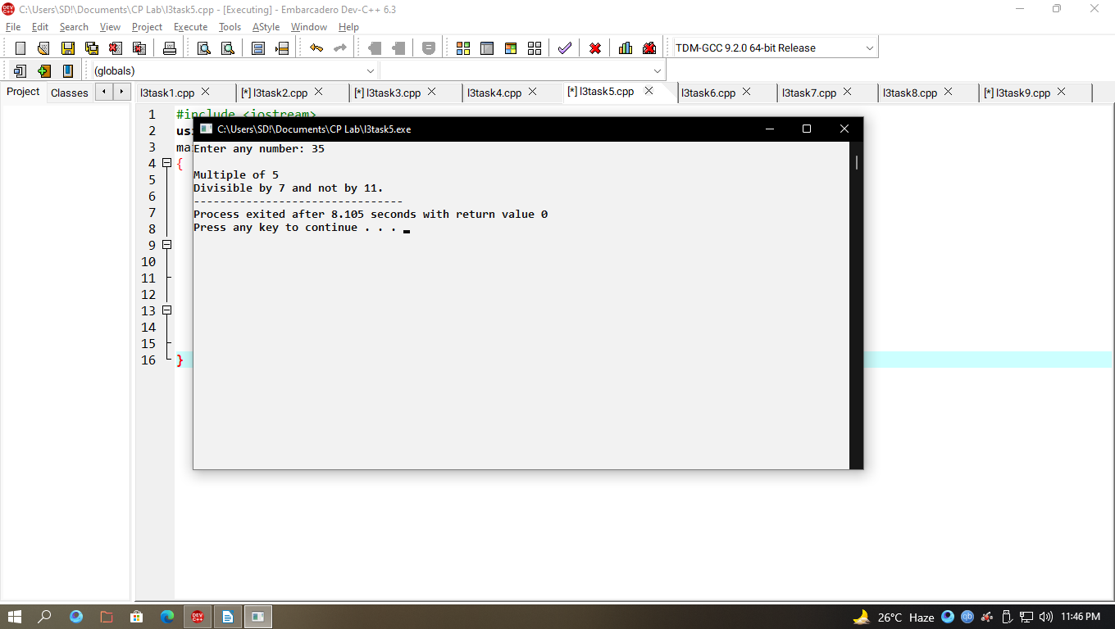

**Task No 06:**

Check whether the entered character is vowel or consonant?

Code

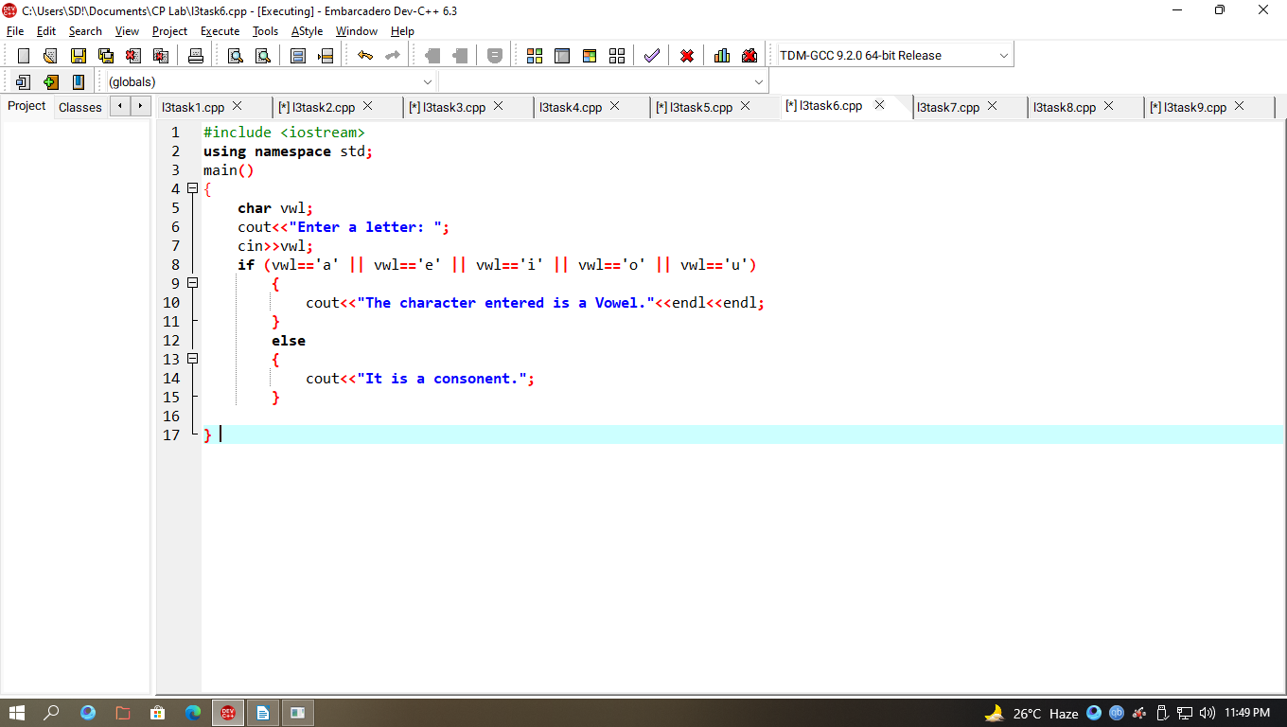

Output

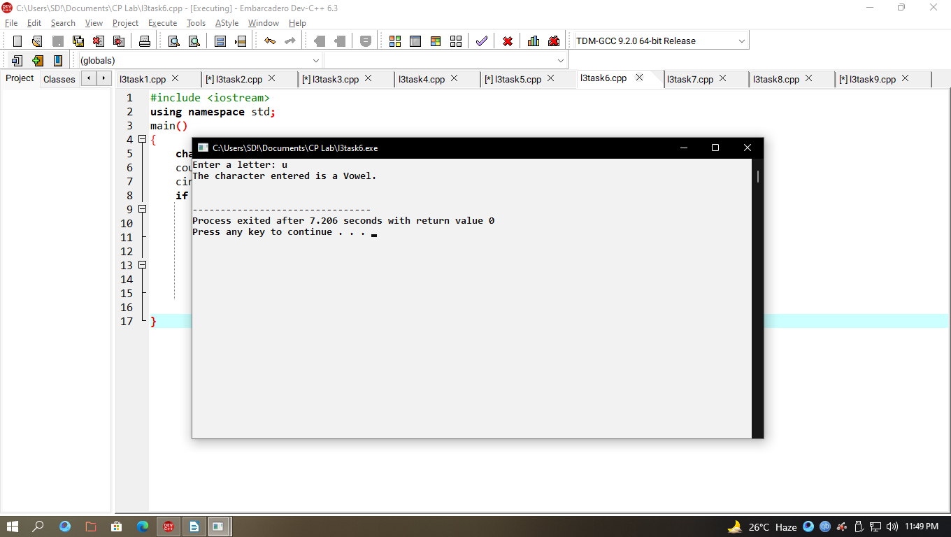

**Task No 07:**

Write a program that takes the weekday number as input from user and print the day name of week.

Code

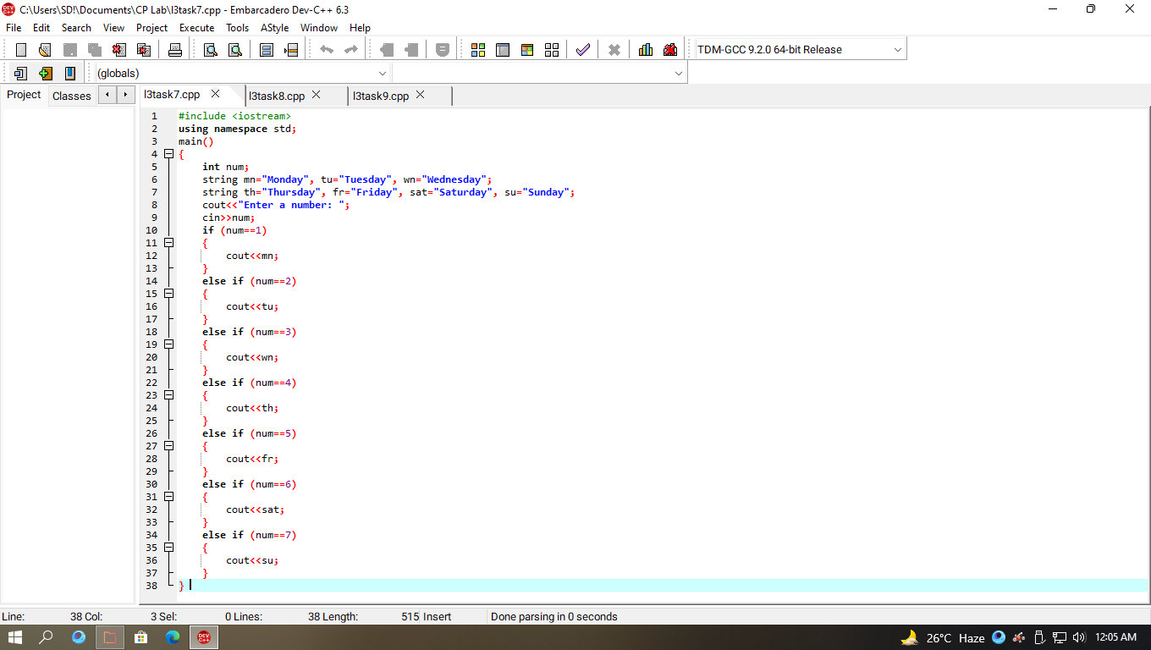

Output

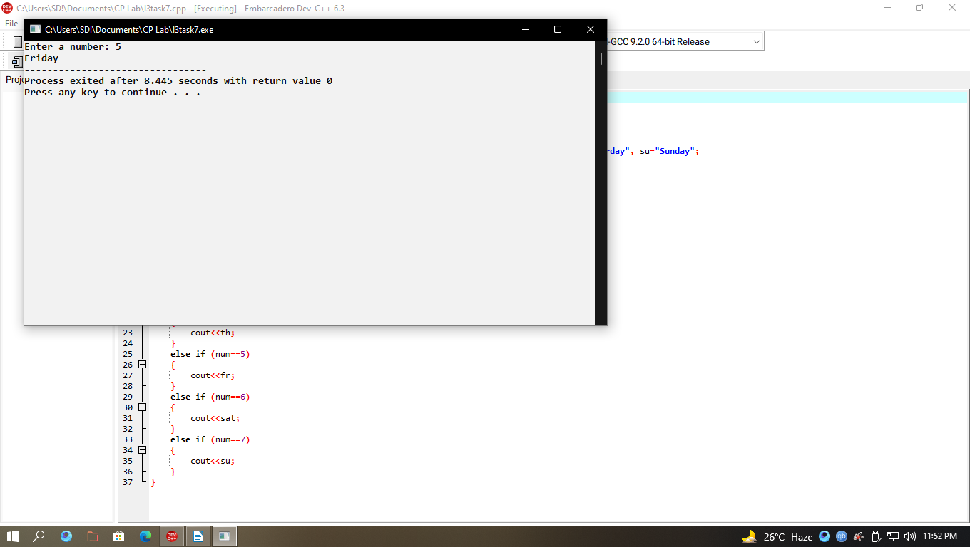

**Task No 08:**

Write a C++ program to enter month number between (1-12) and print number of days in month.

Code

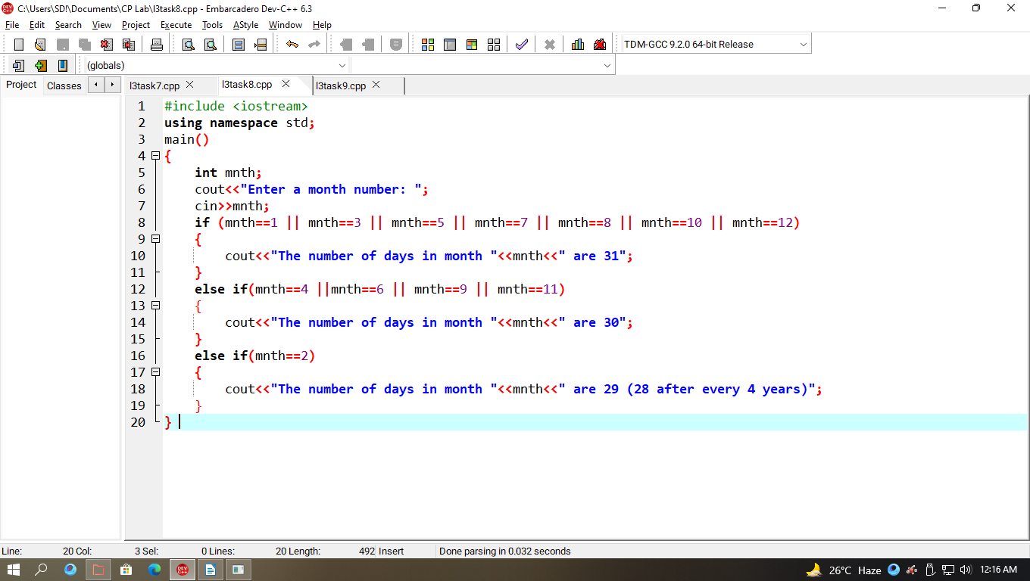

Output

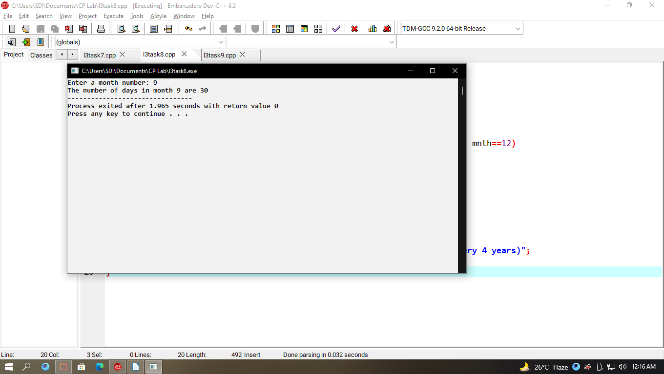

**Task No 09:**

Write a program to calculate and print the Electricity bill of a given customer. The customer id and unit consumed by the user should be taken from the keyboard and display the total amount to pay to the customer

Code

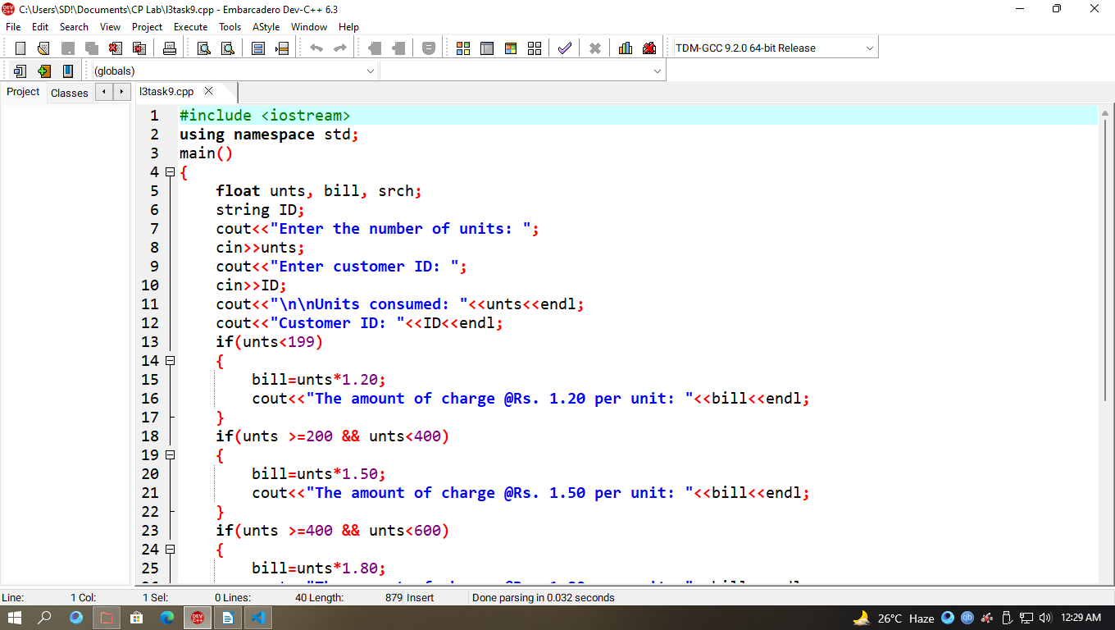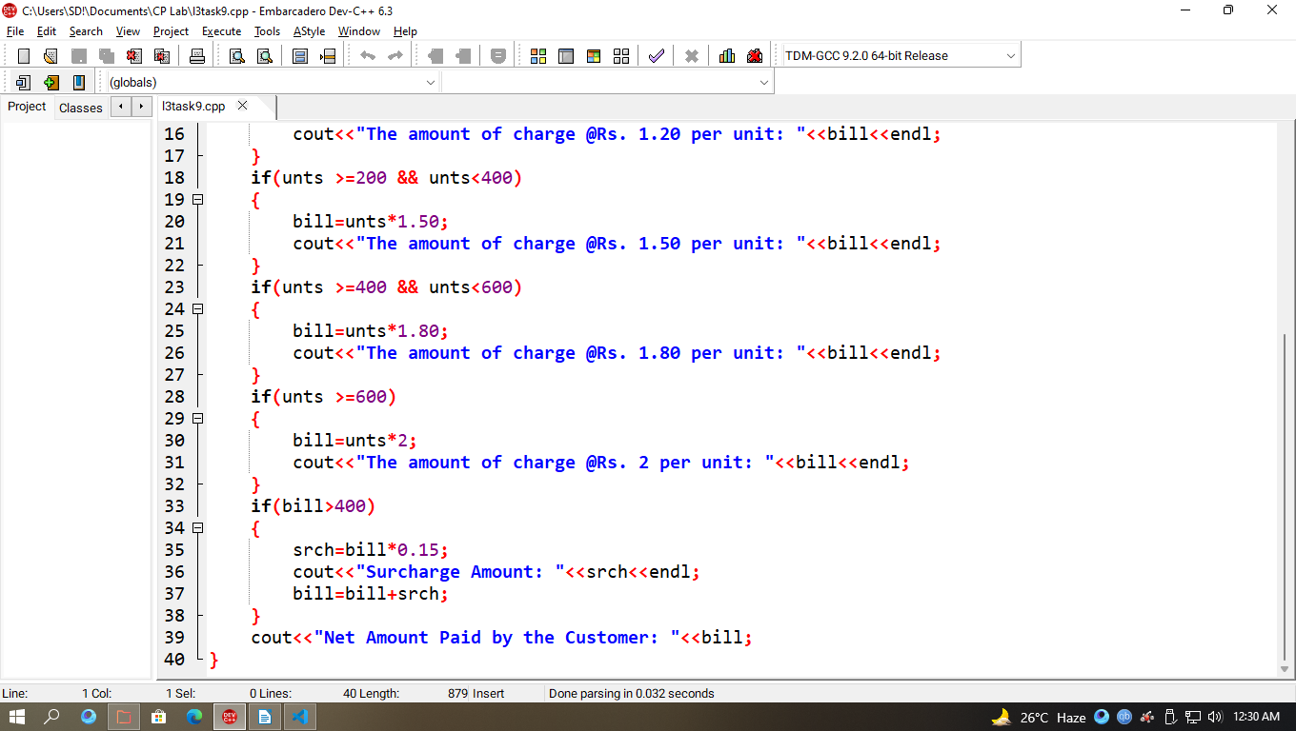

Output

